Step 1: Run importsm
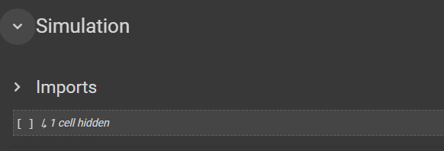

Step 2: Specify ratio and City
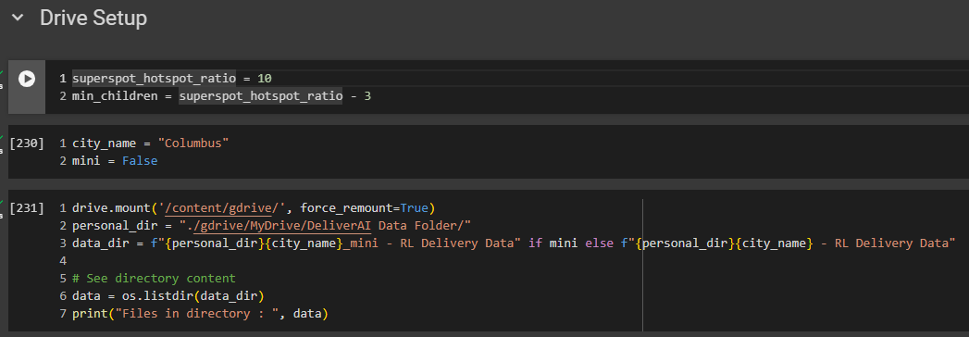

Step 3: Load data, create classes and functions
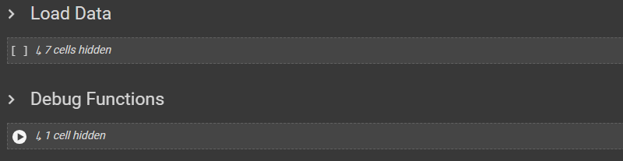
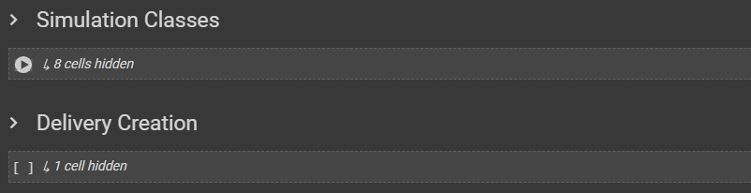

Step 4: Create variables for base delivery set
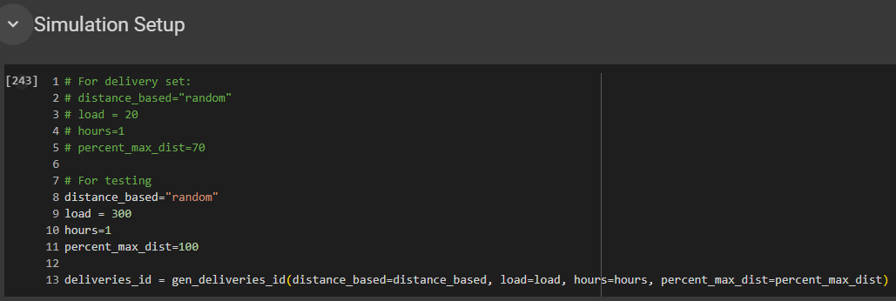

Important: SKIP THE CODE BLOCK BELOW UNLESS DELIVERY SET DOES NOT EXIST

Step 5: Compute threshold Percentage

Step 5.1: Load delivery set, make sure matrix data and time limits are correct
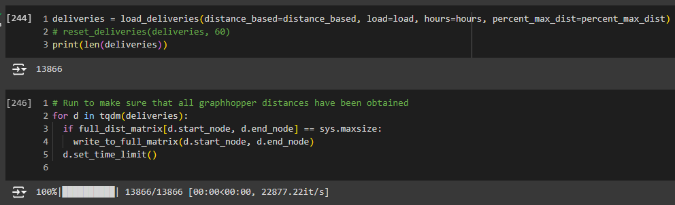

(Optional) Observe distribution of time limits
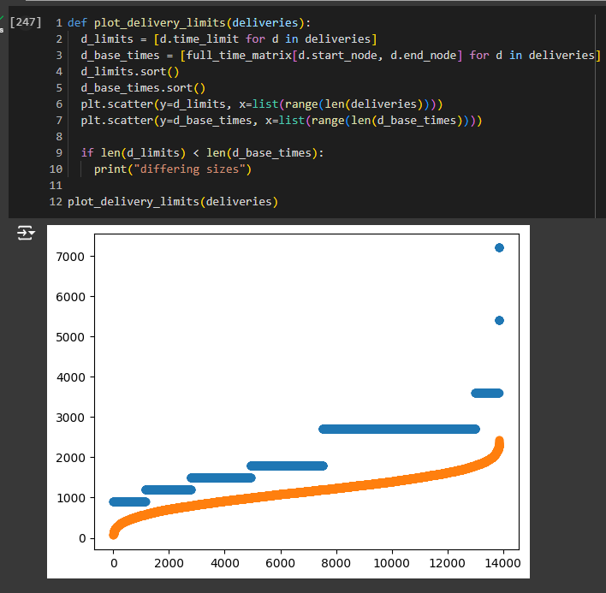

Step 5.2: Get Threshold Percentage
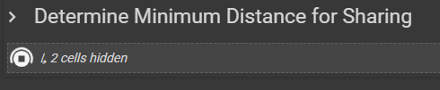
Note: Once graph is done generating, record the provided percentage in Variable Combinations
Step 6: Run the simulation
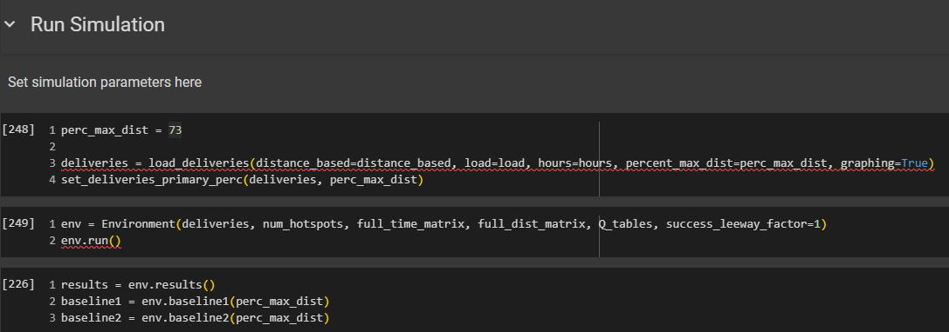
Note: Make sure to specify prec_max_dist as observed in the previous step

(Optional) Print results and check
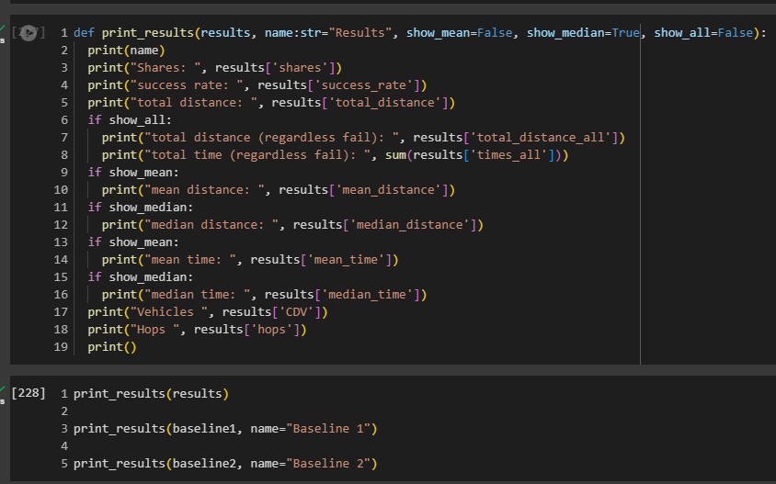
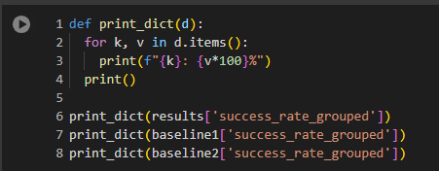

Step 7: Save results to file
